Generated dataset:

X = np.array([

[50, 1.1, 180],

[60, 1.2, 190],

[20, 1.3, 200],

[70, 1.4, 210],

[10, 0.8, 100],

[60, 0.7, 110],

[20, 0.6, 120],

[20, 0.8, 150],

[30, 0.9, 150],

[30, 1.0, 160],

[30, 0.8, 160],

])

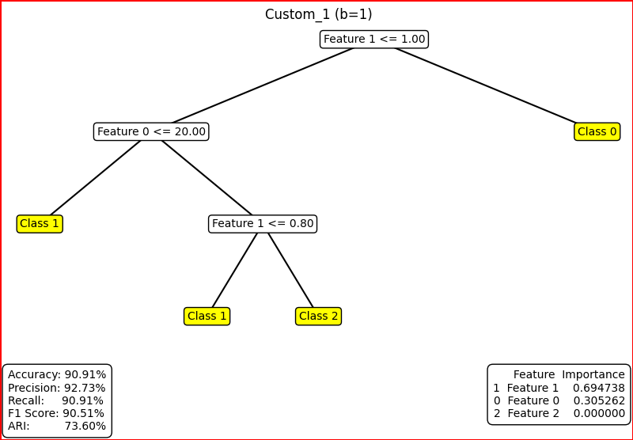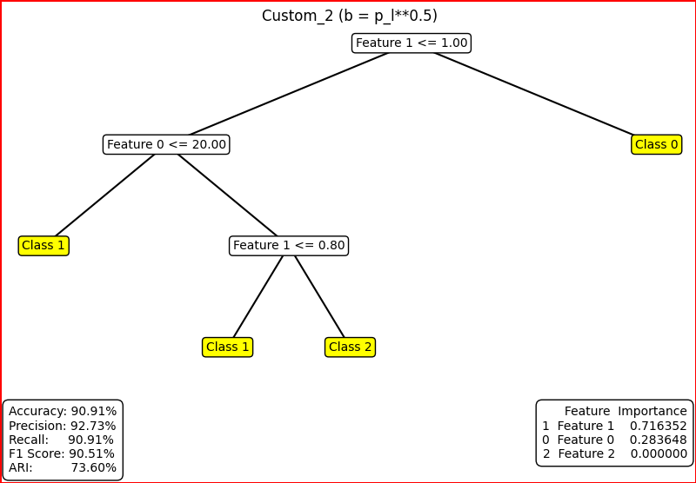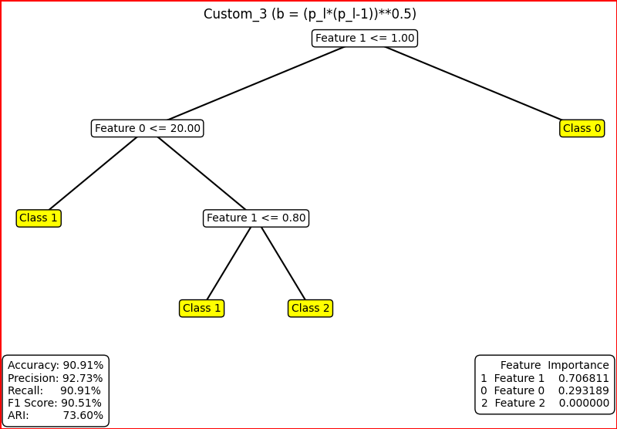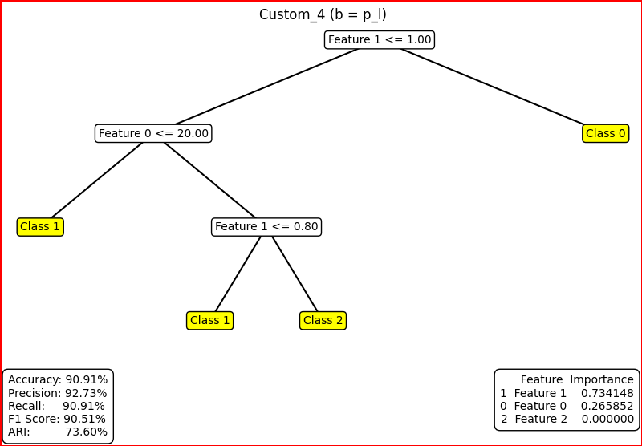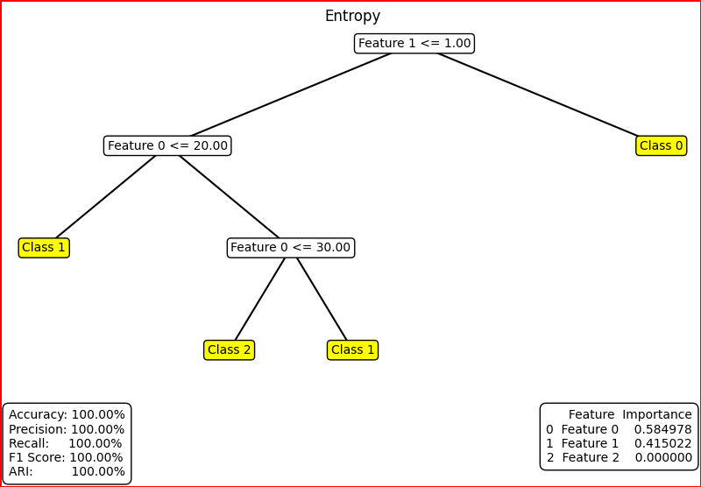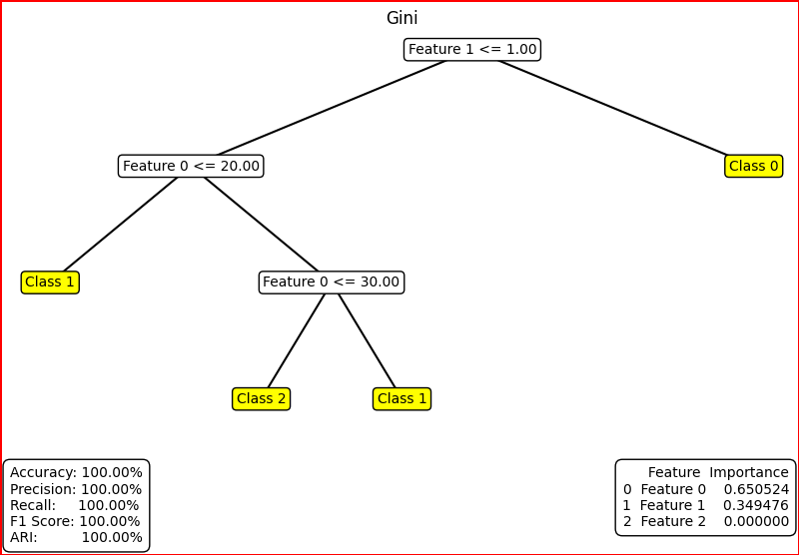

Maximum ARI: ari_entropy and ari_gini = 1.0000